|  |  |
| --- | --- |
|  | **FPT ACADEMY INTERNATIONAL**  **FPT – APTECH COMPUTER EDUCATION** |

**Centre Name: ACE-HCMC-2-FPT.**

**Address: 590 Cach Mang Thang 8, District 3, Ho Chi Minh City, Viet Nam.**

**[NOBEL PRIZES]**

|  |  |  |
| --- | --- | --- |
| **Supervisor:** | Phạm Thị Lánh | |
| **Term:** | T1.2203.M1 | |
| **Batch No:** | 1 | |
| **Group No:** | 1 | |
| **Order:** | **Full name** | **Roll No.** |
| 1. | Lâm Quế Phương | Student1370221 |
| 2. | Nguyễn Thảo Trí | Student1371439 |
| 3. | Huỳnh Minh Quân | Student1373762 |
| 4. | Nguyễn Đức Khiêm | Student1371454 |
| 5. |  |  |

Month **06** Year **2022**

This is to certify that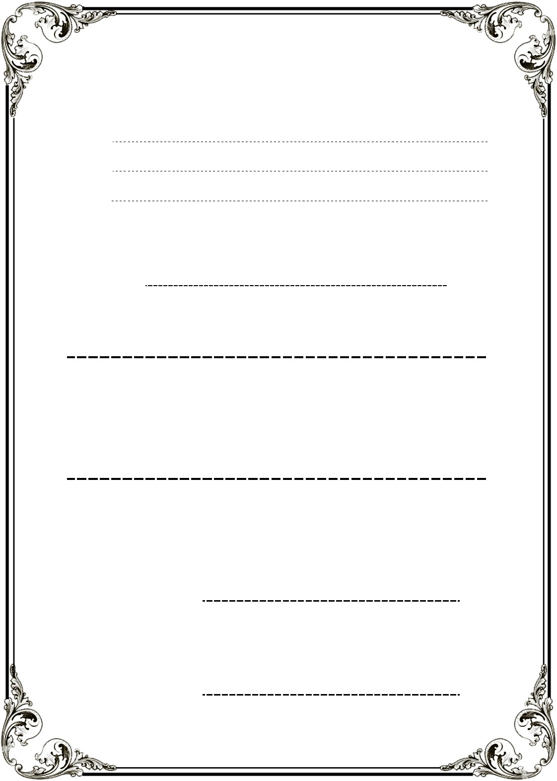

Have successfully Designed & Developed

Authorize Signature:

Date Of Issue: July, 2022

**NOBEL PRIZE**

MR. NGUYỄN THẢO TRÍ

MR. NGUYỄN ĐỨC KHIÊM

MS. LÂM QUẾ PHƯƠNG

MR. HUỲNH MINH QUÂN

Submitted by: **Ms. PHẠM THỊ LÁNH**

# Content

Content 3

Acknowledge 4

Synopsis 5

Review 1 6

Problem Definition 7

Customer Requirement Specifications 7

Architecture and Design of the project 9

Site map 9

Screen shots 10

Home 10

Prize 11

Alfred Nobel 13

Event 14

News 15

FAQs 16

Task Sheet 17

Review 2 18

Home 19

Prize 20

Alfred Nobe 24

Event 25

News 26

FAQs 27

Task Sheet 28

Final Checklist 30

Reference Material 31

# ACKNOWLEDGE

As we understand eProject is another way to learn by building a website that is 80-90% similar to the websites many companies have. It was a project where we had to execute the processes as if we were building a website that our client wanted. The benefits of doing take part in this project are:

* Being able to make a plan for the whole process
* Enhance skills and value
* Have the opportunity to find more ways to build a website in a more minimalist way
* Improve group-work skill
* Learn how to express what we do in our project through words
* Work on real-life projects
* Able to use a different program to design layout
* Understand how important self-learning is during the main course

We want to thank our professor, Ms. Pham Thi Lanh who supported us during the project when we had any problems.

During the project, we made several mistakes and that is an enormous experience for us to widen our knowledge in web development.

Last but not least, we extremely appreciate that India Aptech has allowed us to study and do this project. We will take advantage of this opportunity to learn as much as we can and do our best so that in the future, we will be able to succeed and proud that we are studying at Aptech.

# SYNOPSIS

This project is given to students who have completed the HCJS and AJS courses. However, during the activity, students were able to find and use more languages that support us to gain more information.

The objective of this program is to give a sample project of working on a real-life project. We have to make a plan and follow it step-by-step to get the result and understand how important to work as a team to create a useful and large website.

Before starting to take part in the process, students have to be able to use HTML, Javascript, and AngularJS to build the web. Another no less important is understanding English so that can get what the project required and do the report.

During the development, students need to update the process frequently and come to lab sessions with the assistant based on the schedule. Also, the report is required.

After finishing the website, the advantages that students will take are:

* Understand the process of building the website
* Able to express logical things through words by giving presentations and writing report
* Can write the essay to express what have done
* Have experience in web development
* Team-work experience

# REVIEW 1

# Problem Definition

Nobel Prizes are awarded in the fields of Physics, Chemistry, Physiology or Medicine, Literature, and Peace (Nobel characterized the Peace Prize as "to the person who has done the most or best to advance fellowship among nations, the abolition or reduction of standing armies, and the establishment and promotion of peace congresses"). In 1968, Sveriges Riksbank (Sweden's central bank) funded the establishment of the Prize in Economic Sciences in Memory of Alfred Nobel, to also be administered by the Nobel Foundation. Nobel Prizes are widely regarded as the most prestigious awards available in their respective fields.

# Customer Requirement Specifications

|  |
| --- |
| **LAYOUT** |
| * The Home Page should be created with proper sections, graphics and with a suitable logo * Videos of important inventions should be included (size limit should be considered) * Link on the home page must be included: Home, About us, Gallery etc * Each category mentioned above should brief user about respective topic. * Must be made user friendly and uniformity in the color combination must be maintained. * Navigation of the project must be made smooth. * Must have Site Map |

|  |
| --- |
| **WEBSITE SHOULD INCLUDE** |
| * How and when Nobel Prize awards started * Various fields in which Nobel prize is awarded * Nominations in all field in all years * Details of winners along with their career brief to be included. * Related news * Related event * Gallery * FAQs |

|  |
| --- |
| **HARDWARE/SOFTWARE REQUIREMENT** |
| **Hardware**   * A minimum computer system that will help you access all the tools in the courses is a Pentium 166 or better * 64 Megabytes of RAM or better |
| **Software**   * Notepad/HTML editor * Dreamweaver * IE 5.0/ Netscape 6.0 |

# Architecture and Design of the project



**HTML**

**CSS**

**JavaScript**

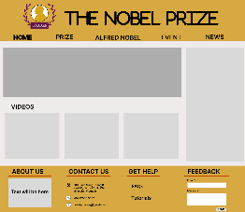

# Site map

# Screen shots

# Home

**Description:**  This is a ***Home*** page of Nobel Prize, at the header area which is on the top contain the logo of the website and the name. Right below that area is the navigation bar which have Home, Prize, Alfred Noble, Event and News sections. In the main part of this page, first area will be the slider about some images which are related. Below that which be the other slider but this one will contain the videos. Also on the right slide, there will be the sidebar where we put some news in that area. Finally, in the footer, the information about the website, way to contact, FAQs and feedback area will be there.

# Prize

**Description:**  When user click on ***Prize*** tag in the navigation bar, it will lead to this page. The main part will have 2 section: the first section will have and bar which have 5 tags for 5 main fields which user can click to select specific field they want. The second section will have the table which contain some random winners of each field.

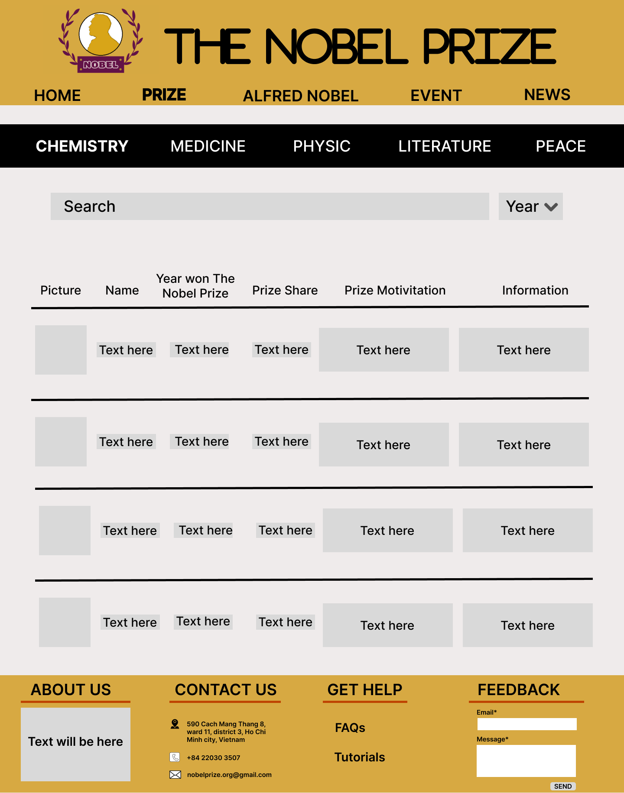

**Description:**  When user click on any tag field, this page will appear, it will show all data of the winners in that filed. Also, the user is able to use the search area to find the specific winner and they can select year to show only winners of that year.

# Alfred Nobel

**Description:**  When the user clicks on the ***Alfred Nobel*** tag in the navigation, this page will appear. At here, all the information, pictures and Alfred’s work will be shown.

# Event

**Description:** After the ***Event*** tag is clicked, the page which contain the events which related to Nobel will be shown right below.

# News

**Description:** After the ***News*** tag is clicked, the page which contain the newest news which related to Nobel will be shown right below.

1. 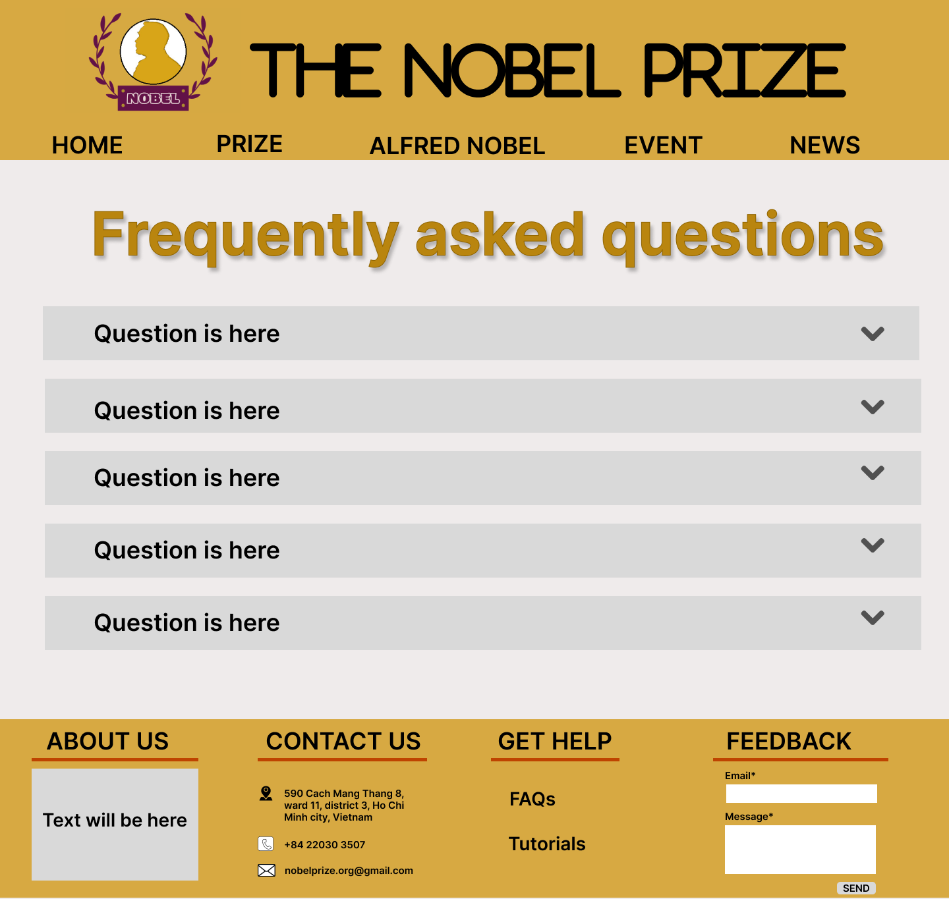**FAQs**

**Description:** When user click on ***FAQs*** in the footer area, this page will be shown with some question about the Nobel prize and the answers will be shown when the arrow at end of the question is clicked.

# Task Sheet

|  |  |  |  |  |  |  |
| --- | --- | --- | --- | --- | --- | --- |
| **Project Ref No.** | **Project Title – The Nobel Prize** | **Activity Plan Prepared by** | **Date of preparation of Activity Plan** | | | |
| **Task** | **Actual Start Date** | **Actual Days** | **Teammate Names** | **Status** |
| Brainstorming ideas for layouts and Project Object | | Quân, Trí, Phương | 21//06/2022 | 1 days | Quân, Trí, Phương | Completed |
| Draw site maps and architecture design | | Phương, Khiêm | 21//06/2022 | 1 days | Phương, Khiêm | Completed |
| Wire framing general page layout | | Quân | 28//06/2022 | 3 days | Quân | Completed |
| Collect static assets (pictures, mp4, documentation,…) | | Trí, Khiêm | 28//06/2022 | 5 days | Trí, Khiêm | Completed |

# REVIEW 2

# Home

# Prize

After we select year

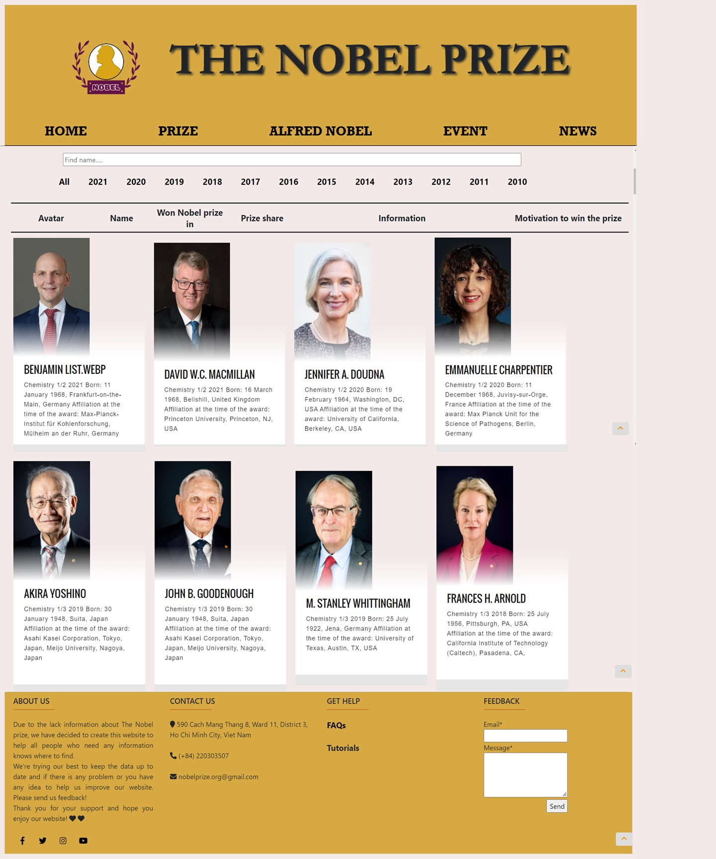

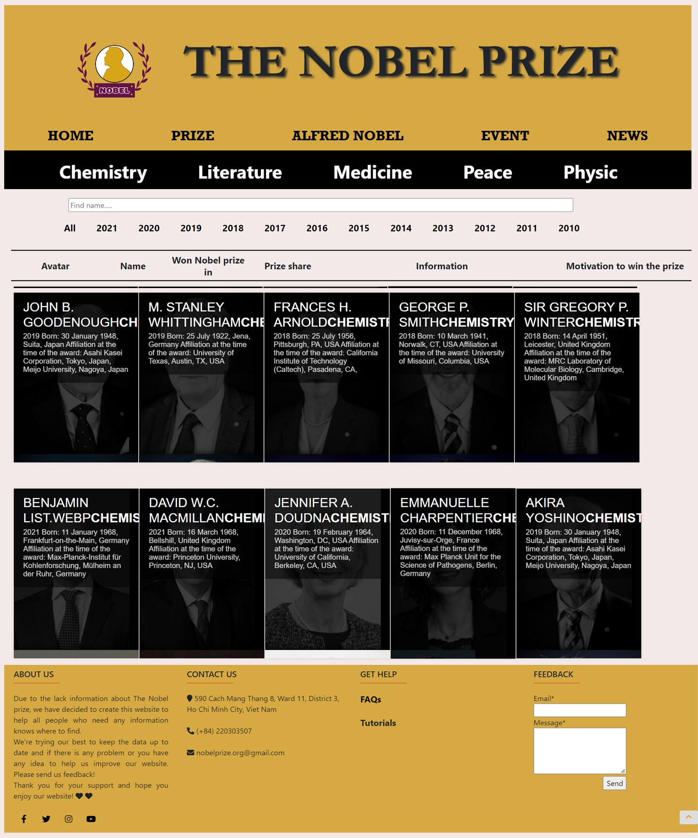After we select the prize

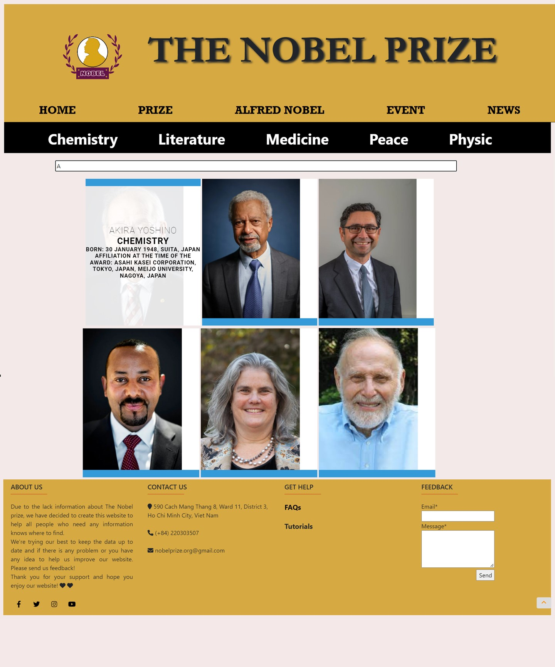After we use search

# Alfred Nobel

# Event

# News

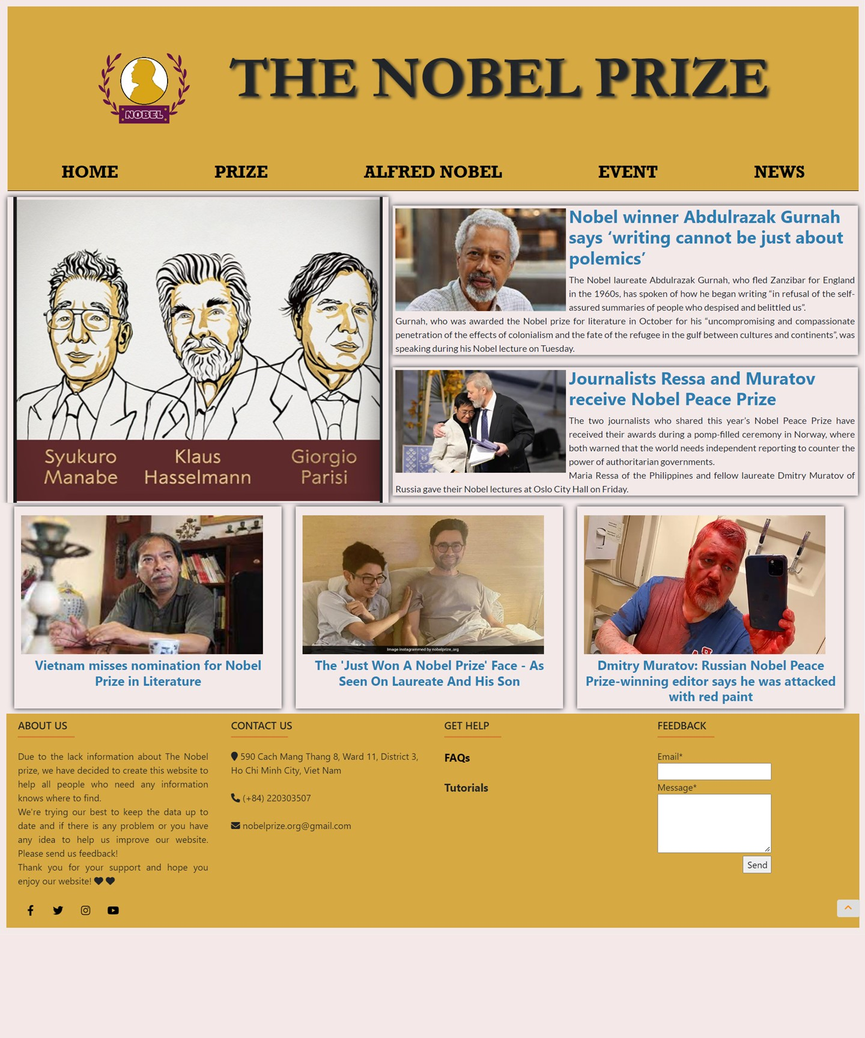

# FAQs

# Task Sheet

|  |  |  |  |  |  |  |
| --- | --- | --- | --- | --- | --- | --- |
| **Project Ref No.** | **Project Title – The Nobel Prize** | **Activity Plan Prepared by** | **Date of preparation of Activity Plan** | | | |
| **Task** | **Actual Start Date** | **Actual Days** | **Teammate Names** | **Status** |
| Design & Built Home | | Quân | 11/07/2022 | 1 days | Quân | Completed |
| Design & Built Prize | | Phương, Quân | 29/06/2022 | 10 days | Phương, Quân | Completed |
| Design & Built Alfred Nobel | | Phương | 11/07/2022 | 3 days | Phương | Completed |
| Design & Built News | | Khiêm | 29//06/2022 | 2 days | Khiêm | Completed |
| Design & Built Event | | Khiêm | 11/07/2022 | 6 days | Khiêm | Completed |
| Design & Built FAQs | | Trí | 19/07/2022 | 1 day | Trí | Completed |
| Design & Built Footer | | Trí | 19/07/2022 | 1 day | Trí | Completed |
| Design & Built Header | | Trí | 19/07/2022 | 1 day | Trí | Completed |
| Push to Github host | | Quân | 21//07/2022 | 2 days | Quân | Completed |
| Write Project Report | | Phương | 21//07/2022 | 2 days | Phương | Completed |

# Final Checklist

|  |  |  |  |  |
| --- | --- | --- | --- | --- |
| **Sr.No** | **Features Tested** | | | **Remarks** |
| 1 | Are all the users able to view the images and links? | | | OK |
| 2 | Have all the views, modules and controllers been | |  | OK |
| properly integrated and is the site function as a single | | |
| page application? | |  |
| 3 | Are the GUI content devoid of spelling mistakes? | | | OK |
| 4 | Is the application user-friendly? | | | OK |
| 5 | Is the Website launching correctly in all popular | |  | OK |
| browsers? |  |  |
| 6 | Are all the forms validated with proper criteria? | | | OK |
| 7 | Do all text links lead to the appropriate website? | | | OK |
| 8 | Do all image links lead to the appropriate website? | | | OK |
| 9 | Are all the images and links clearly visible on the page? | | | OK |
| 10 | Does the Web page work properly in all the tested | |  | OK |
| browsers? |  |  |
| 11 | Does the Web page take too long to be loaded fully? | | | OK |
| 12 | Is the navigation sequences correct through all the Web | | | OK |
| pages on the site? | |  |
| 13 | Is the JavaScript code working as expected in all click | | | OK |

# Reference Material

* Link for the news
* <https://www.theguardian.com/books/2021/dec/08/nobel-winner-abdulrazak-gurnah-says-writing-cannot-be-just-about-polemics>
* <https://aps.org/publications/apsnews/updates/nobel21.cfm>
* <https://www.aljazeera.com/news/2021/12/10/nobel-peace-prize-2021-winners-ressa-muratov-journalism#:~:text=The%20Norwegian%20Nobel%20Committee%20awarded,critical%20of%20the%20Philippine%20government>.
* <https://english.vov.vn/en/culture/vietnam-misses-nomination-for-nobel-prize-in-literature-post925236.vov>
* <https://www.ndtv.com/offbeat/the-just-won-a-nobel-prize-face-as-seen-on-laureate-ardem-patapoutian-and-his-son-2563418>
* <https://www.euronews.com/2022/04/07/russian-nobel-winning-editor-says-he-was-attacked-with-red-paint>
* Link for the information
* <https://www.nobelprize.org/>
* Link for the design
* <https://www.littlesnippets.net/?start=20>
* <https://www.w3schools.com/css/css_rwd_mediaqueries.asp>
* <https://bootswatch.com/>